Course Name | Instructor | Instructor E-mail & Avaialblity
Legal Environment of Business  BUS 216 | Mrs. Katherine Nellis, MBA | kknellis@aps.k12.co.us  Prep Periods: 1st & 2nd  Aftershool: by appointment only
Course Website | Class Meeting Times & Location: | Prerequisites
http://vpbusinesslaw.weebly.com/ | M,T, W/TH, F Room: 2501 | Accuplacer: RC 62 / ACTR 16
 | CCA Withdraw date: 9/6/13 | CCA Drop date: 11/11/13

Course Description
Emphasizes public law, regulation of business, ethical considerations, and various relationships existing within society, government, and business. Specific attention is devoted to economic regulation, social regulation, regulation and laws impacting labor-management issues, and environmental concerns. Students develop an understanding of the role of law in social, political, and economic change.
Learning Outcomes/CCA Competencies
State Core Competencies Standards for BUS216:

Develop an understanding of the legal environment in which businesses operate

Awareness of legal problems and ability to communicate using correct legal vocabulary

Understand the special areas of contracts, personal property, sales, bailments, and commercial paper related to business problems and procedures

Ability to evaluate and think critically about business and legal relationships

Understanding how laws are made, enforced, and interpreted

Increase student awareness of how the law attempts to increase and protect property rights

Ability to locate legal information using the Internet

Awareness of ethical dilemmas

 | Course Outlines and Learning Objectives
Quarter |  | Critical Content/Unit of Study | Student outcomes in measurable terms
1 |  | Ethics and Responsibility | Essential Question: What are basic ethics and how do we express them in our everyday lives  Students will be able to demonstrate understanding of basic ethics and the history of ethics in business.  Students will be able to demonstrate an understanding of ethics in their everyday life.
 |  | Constitution and the Bill of Rights  Amendment I – Tinker v. Des Moines  Amendment IV – TLO v. New Jersey  Amendment XIV – Plessy v. Ferguson  Brown v. Board of Education  Pierce v. Society of Sisters  Amendment V – Gideon v. Wainright Amendment V – Miranda v. Arizona | Essential Question: What are the basics of the Constitution  and the Bill of Rights? How do the Bill of Rights and landmark decisions affect the student’s daily life?  Students will be able to identify and use the Bill of  Rights.  Students will explore and be able to explain landmark cases that influence their lives.
 |  | Courts and Court Procedures  Federal District Courts  Appellate Courts  Supreme Courts  State Trial Courts  State Supreme Courts  Circuit Courts  City Courts  Small Claims Courts  Juvenile Courts  Probate courts | Essential Question: How do the courts operate and what are the differences between criminal law/courts and civil law/courts?  Students will be able to demonstrate an understanding of the federal and state court system.  Students will be able to identify different levels of courts and the specific power of each court.  Students will be able to identify the source of power for the federal courts.
2 |  | Criminal Law  1. Duty  2. Violation of Duty  3. Intent  4. Types of crimes  Procedural Defense  Substantive Defenses | Essential Question: What are the three elements of a crime  and what are the levels of severity of criminal acts?  Students will be able to describe the three elements of a criminal act.  Students will be able to describe the difference between a felony and a misdemeanor.  Students will be able to describe different crimes and the basis for those crime.
2 |  | Civil Law (part 1)  Elements of a tort  1. Duty  2. Violation of the duty  3. Injury  4. Causation  Types of torts  Assault  Battery  False imprisonment  Defamation  Invasion of Privacy  Trespass Conversion  Fraud  Civil Procedure | Essential questions: What are the elements of a tort and the types of torts?  Students will be able to describe the different types of torts and be able to relate them to experiences in their own lives.  Students will be able to describe intentional torts and negligence.  Students will be able to describe and explain strict liability.
 |  | Civil Law (part 2)  Elements of a tort  5. Duty  6. Violation of the duty  7. Injury  8. Causation  Types of torts  Assault  Battery  False imprisonment Defamation Invasion of Privacy Trespass Conversion  Fraud  Civil Procedure | Essential questions: What are the elements of a tort and the  types of torts?  Students will be able to describe the different types of torts and be able to relate them to experiences in their own lives.  Students will be able to describe intentional torts and negligence.  Students will be able to describe and explain strict liability.
3 |  | Contracts  Elements of a contract Offer and Acceptance Genuine Assent Legality  Consideration Capacity Consideration Writing Consideration Creditors  Statute of frauds  Transfer of obligations  Remedies for Breach of Contract | Essential Questions: What are contracts and how do they affect me? What do I need to know to enter the world of contracts and be a good consumer?  Students will be able to demonstrate an understanding of the elements of a contract and all of  the legal components.  Students will be able describe what is required of the people entering into a contract.  Students will be able to describe how contracts are revoked or terminated.  Students will be able to describe the remedies for breach of contract.
4 |  | Employment Law  Duties Hiring Terminating Unions  Worker’s Compensation | Essential Question: What are the employment laws that  influence businesses and how do they influence who is hired?  Students will be able to explain and describe the process for hiring and terminating employees.  Students will be able to describe the role of unions in society and the workforce.  Students will understand the basics of worker’s  compensation and the requirements of businesses.
4 |  | Business Organizations  Sole Proprietor  Partnerships  Corporations | Essential Question: What is the structure of different types of business and what laws impact each? How is a company bound by hiring and employment laws?  Students will be able to describe the different types of businesses and the advantages of each.  Students will be able to describe the roles of people and investors in businesses.
4 |  | Cyber Law  The impact of the internet on society and the law. | Essential Question: How does the growing online community impact students legally?  The students will demonstrate an understanding of current cyber law and how it impacts them.

Standards Based Grading
Standards-based grading measures what a student should know and be able to do at each grade level according to Colorado state content standards. Under the standards-based system, students are graded on their achievement on class content. Work habits such as class participation and attendance are recorded separately.

WHOLE NUMBER SCALE for assignments/individual assessments (minimum expectation)
Proficiency | Number | Teacher Language | Student Language
A | 4 | More Complex Measurement Topic | I completely understand and can apply, evaluate and/or re-create my learning for others
P | 3 | Target Measurement Topic | I can consistently do this by myself
PP | 2 | Simpler measurement topic | I can do some by myself, need help with some
U | 1 | With help partial success at 2.0 and 3.0. | Even with help, I still only understand some of this
F | 0 | No evidence | I showed no understanding at all or did not bother to turn this in

Determining a Quarter Grade:
Average ACROSS measurement topics (summative), NOT within measurement topics (formative).  A quarter grade should represent a student’s learning over time and to that extent summative assessments must play a larger role (at least 70% of a quarter grade) than formative assessments. |  | A=3.00-4.00  B=2.50-2.99  C=2.00-2.49  D=1.00-1.99  F=Below 1.00

Body of Evidence:
There are two types of assessment, formative and summative.

- Formative (assessments for learning) provide direction for improvement for the student and adjustment of instruction for the teacher e.g. observation, homework, discussion, etc.
- Summative (assessment of learning) provide information to be used in making judgments about a student’s achievement at the end of a sequence of instruction, e.g. quizzes, tests, projects, etc.

10% of student’s grades will also consist of a work habits score. Students will self-evaluate their progress in the class bi-weekly. Teachers will then give their input and scores will be averaged.

Work Habits Scale | Responsibility | Effort  (The Path to Mastery) | Participation
(I...)  4=Always  3=Usually  2=Sometimes  1=Rarely | - Complete assignments on time (in-class and homework)  - Attend class daily  - Come prepared  - Respect the learning environment | - Motivated learner  - Exhibit perseverance and persist in the face of setbacks  - Embrace challenges  - Adjust based on feedback | - Actively engage and focus/ SLANT  - Begin work without teacher prompting  - Follow instructions  - Ask and answer questions voluntarily (self advocate)  - Contribute significantly to group work
Student Score
Teacher Score

Classroom policies- Building policies are found in the student/parent handbook and can be found on the VP website.

Concurrent Credit
Students who receive a grade of C or higher may be granted college credit through the Community College of Aurora. They will receive 3 credit hours that have the ability to transfer to various post secondary institutions.

Required/Recommended Supplies
Students should have a binder with three dividers dedicated to this course. The binder should have a good supply of lined paper and include the following sections: Notes, Vocabulary, and Chapter Summaries. Kleenex and Hand Sanitizer is always welcome.

Textbook PROVIDED: Class Textbook: Goldman, A.J. & Sigismond, W.D. (2011). Business Law: Principles and Practices, 8th ed. South-Western Cengage Learning, Mason:OH.

Supplementary Material:
Homework & Parental Engagement/ Support Plan
Homework will be assigned, depending on what is completed in class. There will not be any standard homework dates or assignments, so students are responsible for homework and completion. Students should write homework in their planner daily. In addition, there may be group projects that will require time outside of class to complete.
As a result of the BUS 216 students receiving college credit, they will be held to a higher expectation when it comes to their work. All work is expected to be completed on time and high quality. Late work will NOT be accepted, except for excused absences.
Quizzes
Quizzes will be given on a regular basis to determine growth and maintenance of understanding. Quizzes will be at the end of each lesson/topic. They will be a combination of multiple choice and written responses. Study guides will be provided for students for quizzes.
Exams
Exams will be given to assess student growth and understanding on the State Core Competencies and Standards. Exams will be at the end of each unit. They will be a combination of multiple choice and written responses. Study guides will be provided for students for exams.
Class Participation/Attendance
It is essential that all members of the learning community participate on a daily basis. If an absence occurs and is excused, assignments must be made up within one week of the due date. If student is gone for an extended period time please contact your teacher before or after school. Assignments cannot be made up for unexcused absences. Please refer to the classwork folders and/or the class webpage for missing work.
Responsible Technology Use
All students are given the privilege of utilizing our state of the art technological tools including iPods, iPads, Netbooks, Laptops, Google accounts etc. and are expected to follow the guidelines for technology use as outlined in the Acceptable Use Policy. Students shall not:
· Utilize the school system computer network for any illegal activity.
· Access or link to websites that contain material deemed vulgar, offensive, or otherwise inappropriate.
· Use or display copyrighted or otherwise licensed material without specific permission or authorization
from the appropriate party.
· Utilize the network for commercial purposes.
· Post, use, or download any files that cause congestion or impede network operations.
· Trespass in or vandalize another’s files, folders, data, or work.
· Post anonymous messages or in any way misrepresent one’s own identity.
· Use an account password of another user.
· Use abusive or otherwise objectionable language in any message.
· Use e-mail to promote the annoyance, attack, or harassment of others.
Consequences for misuse may include, but are not limited to, suspension of equipment access, disciplinary action commensurate with the level of misconduct, and/or legal action as appropriate.

I have carefully read the expectations of this course and agree to support the goals and initiatives of the course. I will show up, speak up, stand up and go further than I ever thought possible.

Student name: _____________________________________________(print) Grade _______ period _________

Parent/Guardian Name: __________________________________________ (print)

Parent/Guardian Name: __________________________________________ (Signature)

Parents and students: Sign up for notifications!

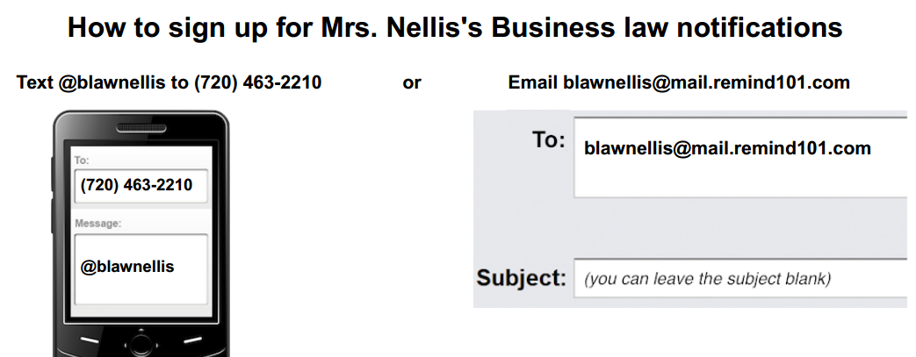

To opt-out, text 'unsubscribe @blawnellis' to (720) 463-2210. Standard text message rates apply.

